From the Isle of Music/Uncle Bill's Melting Pot e Texas Radio ShortWave ritornano su channel 292 e stanno testando frequenze e orari.

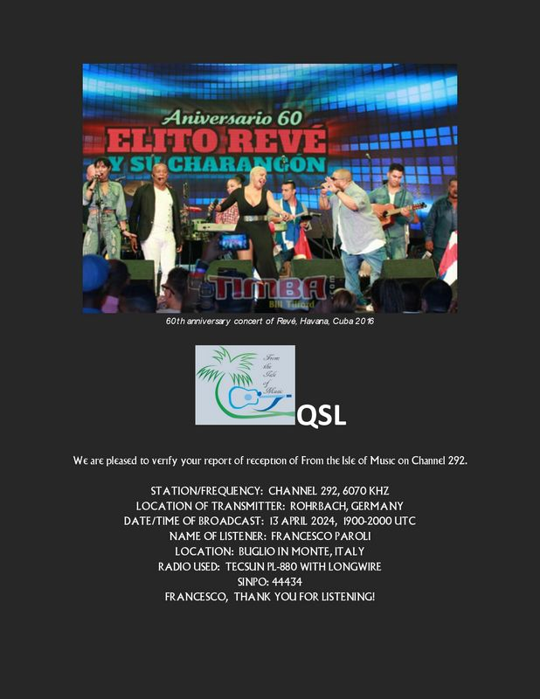

From the isle of music 6070 kHz, eQSL ricevuta in 6 ore per un rapporto di ricezione
spedito il 14/04/24 via Email a: tilfordproductions@gmail.com

Francesco,
It is great to hear from you again after all this time.
9670 was very disappointing today, we will try it again to rule out an accident of propagation but will change it if it does not improve.
Next week, my world music program, Uncle Bill's Melting Pot, will be on at the same times and frequencies plus an experimental simulcast on 3955 to see how it does.
IN the meantime, an eQSL is attached, and I hope you enjoy our future programs.

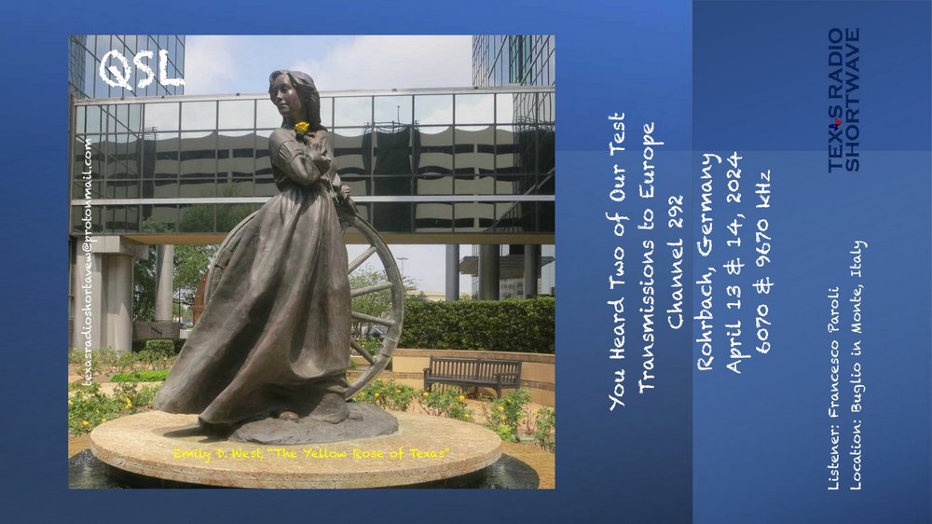

TRSW 6070 e 9670kHz, eQSL ricevuta in 1gg per un rapporto di ricezione spedito
il 14/04/24 via Email a: texasradiosw@gmail.com
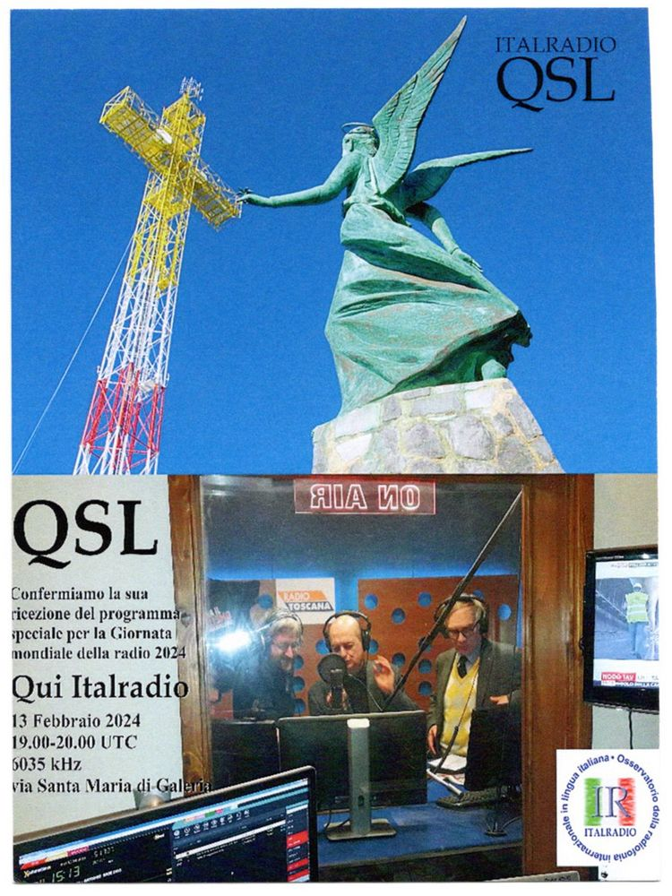

Italradio 6035 kHz, QSL ricevuta in 34gg per un rapporto di ricezione spedito il 13/02/24 via Email a: web2012@italradio.org

